PROFILE:

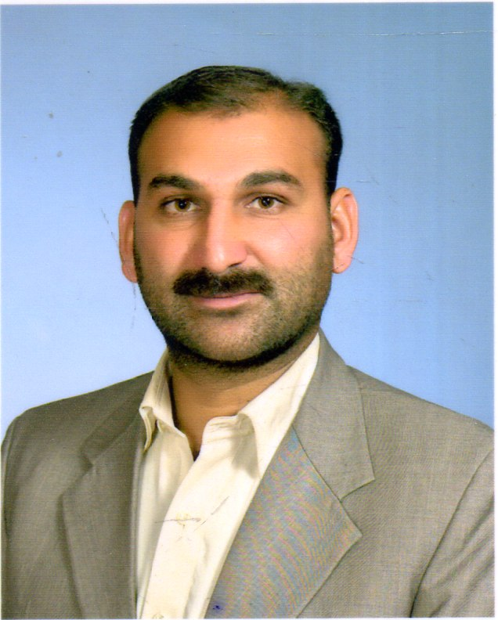

Contact

 +92 3459464462
tallatpervez79@gmail.com

JEDDAH,SAUDI ARABIA
Iqama : Transferable
Nationality: Pakistani
Date of Birth: 07-04-1979

QUALIFICATION

SKILLS
- Supervising Staff
- Public Relations
- Team management
- Leadership
- Problem Solving
- Interpersonal
- Communication
- Planning
- Decision Making

Languages
- Urdu
- English
- Pashto
- Arabic
- Punjabi
I want to joiner in your esteemed company or project with 10 years of experience in administration field. I am experienced in facilities and administrative work. I want best work opportunities in respectable company or Project. I am an experienced worker with good administrative skill and experience in groundwork. I am seeking employment in a company which makes best use of my work experience and give me opportunity to develop them further. I am a punctual, honest, organized, responsible and motivated individual. I am always enthusiastic to learn and undertake new challenges. I am searching a good job position where I can serve my experience, leadership skill and passion for innovation with a significant impact and contribute to the success of a company or Project.

PROFESSIONAL EXPERIENCE:
1 – Facilities Supervisor:
(2014 – 2017)
Almathaaq advanced Company Limited at Jeddah (Saudi Arabia).
- Completion of the day-to-day facilities work of company.
- Maintaining purchase record of maintenance items on daily basis.
- Supervising and monitoring the maintenance staff and other workers.
- Reporting to department manager to daily facilities work.
- I used to do all the tasks given to me by company faithfully.
- Supervising the work on special events. Assisted in event management work.
2 - Coordinator:
MASTER OF ARTS

(2013 – 2016)
I did work highly organized and professional method with 3 years of experience as coordinator at (King Abdul Aziz International airport) Jeddah Saudi Arabia.
- During the hajj mission all kinds of support were provided to the hajj pilgrims from landing at the airport to accommodation.
- My role was to give assistance and awareness to pilgrims on airport.
- Solved of the transportation, accommodation and health issues of pilgrims.
- Given complete guidance to pilgrims in any inconvenience on airport.

3 - Group Secretary:
(2005 – 2008)
- Providing financial support to deserving people e.g. widows, destitute, orphans, women empowerment projects and victims of natural disaster.
- Identify families and individuals affected by natural calamities such as earthquakes, floods, storms and famine in a transparent manner by allocating money to them. Assist in preparing bills and travel documents of project.
4 - Admin Supervisor:
(2000 – 2003)
I have served in the mentioned position in the administration department of Pakistan International airlines. I had the following responsibilities:
- Organizing employee records and benefits paperwork. Arranged daily work plan.
- Provided general administrative assistance to the HR officers and team.
- Arranging transportation and accommodation for visitors and event manager.
- Providing logistic support and keeping record of daily purchase items.

